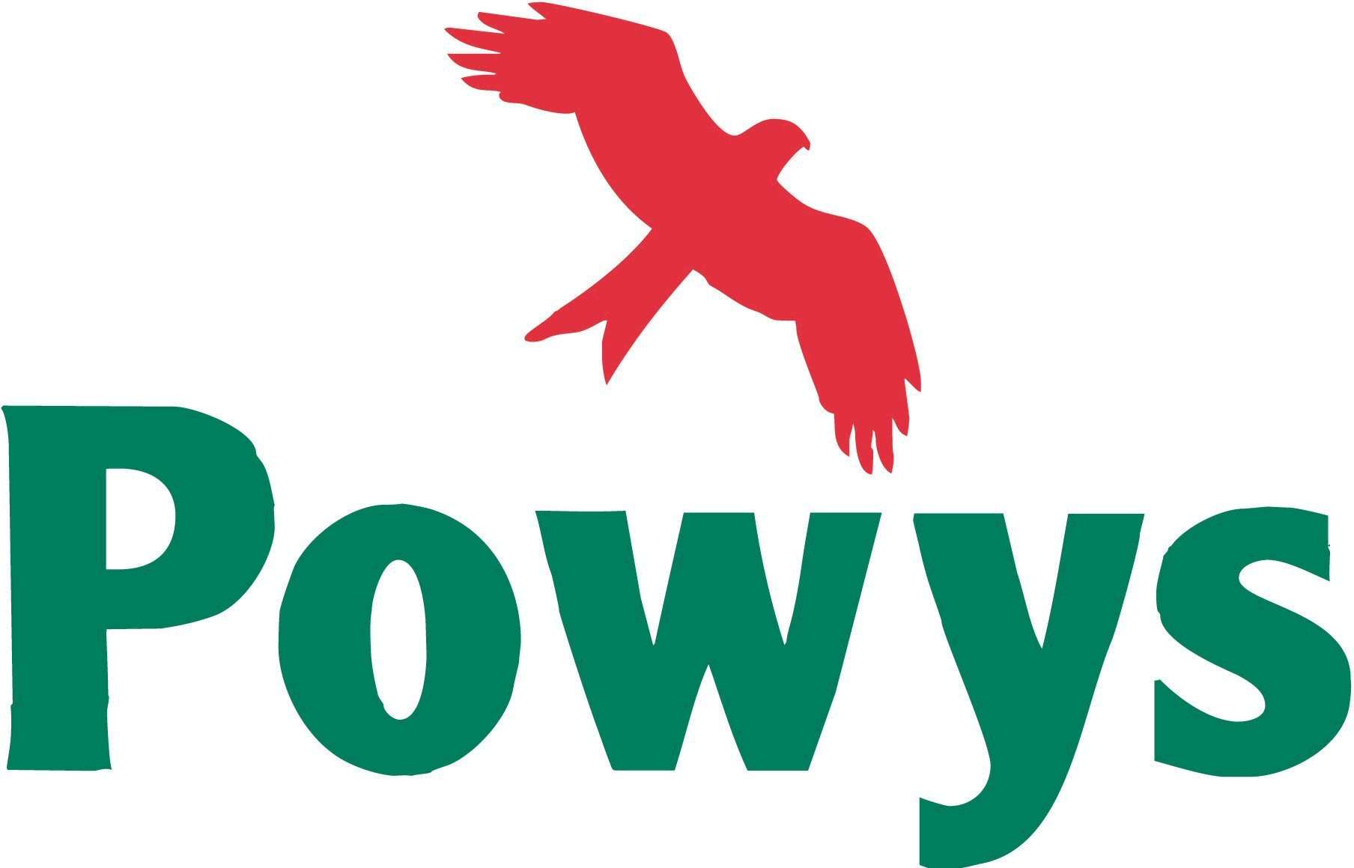 | For Office Use
 | LDP Representor No:
 | Date received:
 | Action: / scanned / copied / acknowledgement / entered:

Adopted Powys Local Development Plan 2011-2026

Draft Supplementary Planning Guidance (SPG) Consultation
Representation Form July 2018

It is recommended that representations are made on this standard form. A separate form is available for each different SPG. More copies are available at Powys Council offices and at local libraries where the Draft SPG is available for public inspection or online at www.powys.gov.uk/ldp

Please use this form to comment on the Planning Obligations SPG.

Send your completed form to:

Powys LDP Team
Planning Policy
Powys County Council
The Gwalia,
Llandrindod Wells,
LD1 6AA or via email to LDP@powys.gov.uk

Representations must be received by 5.00 pm, Tuesday 21st August 2018.

Group Representations

Where there are groups who share a common view on matters contained within the SPG it would be very helpful for the group to send a single representation which represents that view. Groups should indicate how many people they represent and how the representation has been authorised. The group’s representative should be clearly identified.

Data Protection

Personal Data will be processed in accordance with the General Data Protection Regulations 2018 (GDPR). We collect the data to ensure good practice - openness, transparency and collaboration - in the way the Council carries out its statutory planning functions under Part 6 of the Planning and Compulsory Purchase Act 2004.

Powys County Council will be data controller for any personal data you provide as part of your response to the consultation. The data is stored in the LDP digital database and each person/organisation is given a unique identification number. We will only use the data for the purpose of the LDP process including the preparation of supplementary planning guidance (SPG) and do not share the information unless obliged by law to disclose it.

Any comments that you send to us will be seen in full by Planning Policy staff dealing with the issues which this consultation is about. In order to show that the consultation was carried out properly and to inform the public, the Council intends to publish a summary of the comments made to the consultation. We do not routinely publish comments in full, however, in certain circumstances we reserve the right to publish comments in full which may include the name of the person or organisation who sent the comments together with a unique identification number. If you do not want your name published, please tell us this in writing when you send your response. We will then redact any identifying information before publishing.
All personal telephone numbers, addresses and email addresses will be treated as confidential.

We will retain your information for as long as required for the purposes outlined above or, to comply with statutory requirements or, unless you ask us to remove it. If you require your data to be removed from the LDP database in accordance with the GDPR you must notify us directly in writing to:
The Planning Policy Team
The Gwalia
Ithon Road
Llandrindod Wells
LD1 6AA
Or by email to LDP@powys.gov.uk

Please note that if you request removal from the database you will receive no further consultations in connection with the LDP and SPG.

Under the GDPR, you have the right:

- to be informed about the collection and use of your personal data.
- to access your personal data.
- to have inaccurate personal data rectified.
- to request the restriction of personal data (in certain circumstances).
- to object to the processing of your personal data
- to lodge a complaint with the Information Commissioner’s Office (ICO) who is the statutory regulator.

For further details about the information the Council holds and its use, or if you want to exercise your rights under the GDPR, please see contact details below:

Data Protection Officer
Powys County Council
County Hall
Spa Road East
Llandrindod Wells
LD1 5LG
or, email: Information.Compliance@powys.gov.uk
or, http://www.powys.gov.uk/en/information-mangement/data-protection-and-privacy/

Please note that information provided in Section 2 will be made publicly available. Personal data but excluding your name, as provided in Section 1, will be treated confidentially and will not be made publicly available.

SECTION 1: Personal Information – please complete this section.

 | Your Details | Agent’s Details (if applicable)
Name:  NB. Your name may be published with your comments. | Presteigne and Norton Town Council
Tel: | 01547 528575
Email: | pntc@hotmail.com
Address: | Garn Farm,  Chapel Lawn  Bucknell  Shropshire  SY7 0BT
Signature: | Tracey Price
Date: | 19.07.18
Representor Number *: | 525

*You will have a Representor Number if you have made representations at any time during the LDP process or if you have requested to be included on the Council’s LDP database. The Representor number will be clearly indicated on previous correspondence from the Council/Programme Officer. PLEASE QUOTE THIS NUMBER TO ASSIST THE COUNCIL IN IDENTIFYING YOU IF YOU ALREADY HAVE A NUMBER.

If you have not previously made representations and you now want your personal details to be added into the LDP database to receive future communications concerning LDP matters (note data protection notice above) please indicate your consent here:

Please add my personal details into the LDP database: YES / NO (Strike through as required).

SECTION 2: Commenting on the draft Planning Obligations SPG:

Please answer the following questions as appropriate and set out your comments below using additional sheets as necessary. Clearly indicate using page numbers and/or paragraph numbers to show which part of the SPG you are commenting on. Outline what changes you think are needed or what additions/deletions should be made:

PO1 - Do you agree with the Council’s approach not to pursue a CIL Charging Schedule at this point in time? If not, please explain why.

Yes providing consultation is made with the relevant Town and Community Council as the S.106 is being drawn up and that T or CC is fully involved with the process.

Given the size of most Community Councils it is difficult to separate the planning and planning gain processes and it therefore much easier if the planning gain consultation is carried out at a later stage in the process when there is no reason for the public to suspect that planning permission is being bought.

.
PO2 - Do you agree that, in the interests of avoiding duplication, this SPG only cross-references to policies in the LDP and does not repeat them? Would you prefer the SPG to include the applicable policies? Is so, should they appear in the main document or in an Appendix?

No view.

PO3 - Due to the nature of planning obligations, this SPG cannot include every scenario/detail. Do you think the document is clear in this respect? Do you agree that it enables officers, stakeholders and developers to understand that additional or alternative obligations may be sought? If not, please explain why.

No comment.

PO4 - Do you agree that “major” development should be the development that most often triggers obligations? If not, please explain why.

Please detail any changes towards seeking obligations that you think may be suitable and relevant for Powys citing examples from other planning authorities where known.

Nb. Definite targets/thresholds, where set within the LDP, are not negotiable at this point and would only be re-assessed at the Plan Review stage.

Yes.

PO5 - Do you consider the Step by Step Flowchart in Figure 1 to be clear and accurate? If not, what changes would you suggest? If you have experience of the process within Powys County Council, does this flowchart mirror your experience?

Include consultation on S.106 details with Town and Community Councils.

PO6- Do you agree with the approach that it is the Affordable Housing SPG and not this SPG which includes the arrangements for assessing the financial viability of a specific development?

No comments.

PO7 – Whilst there is no statutory requirement to specify a time period in which planning contributions should be spent, do you agree with the suggested 10 year (maximum) period? If not, please explain why.

Yes.

P08 – Do you consider that the five main topic areas set out in Part 3 are the right topic areas for this document? If not, please explain what changes you would like to see and why.

No view.

PO9 – Do you agree that the detail provided in Part 3 for the various topic areas is relevant and sufficient to inform S.106 negotiations? If not, what changes would you like to see and why?

No comments.

PO10 - Do you agree with the methods and formulae (where provided) for calculating the required financial contributions as set out in Part 3? If not, please explain why.

No comments.

PO11 – If you have any other comments you want to make which are not covered by the above questions please include them here:

Given the County Council will not adopt any play areas created it does not seem sensible to rely on developers to do so – they may not even still be in operation five years on from the development. If play areas continue to be requested then securing their long term future maintenance should be addressed

The Town Council was pleased to see that a dedicated monitoring and enforcement officer is in post to maintain a register of obligations and provide enforcement to ensure compliance. This must be continued.

SECTION 3: What Happens Next?

Planning Policy Wales (9) says in para. 2.3.4 substantial weight can be given “to approved SPG which derives from and is consistent with the development plan, and has been the subject of consultation.” The preparation of SPG however, is not subject to the same statutory process as an LDP. Following this consultation, the Council will review the comments received and make amendments as considered appropriate. A final version of the SPG will be approved by the Council, published on the website and will become a material planning consideration. No Public Examination will be held to consider the draft SPG. Further details can be found on the Powys website: www.powys.gov.uk/ldp.

Completed representation forms must be returned:
BY EMAIL - LDP@powys.gov.uk, or,
BY POST – The LDP Team, Planning Policy, Powys County Council, The Gwalia, Llandrindod Wells, Powys. LD1 6AA

The closing date for representations is 5.00pm Tuesday 21st August 2018.

