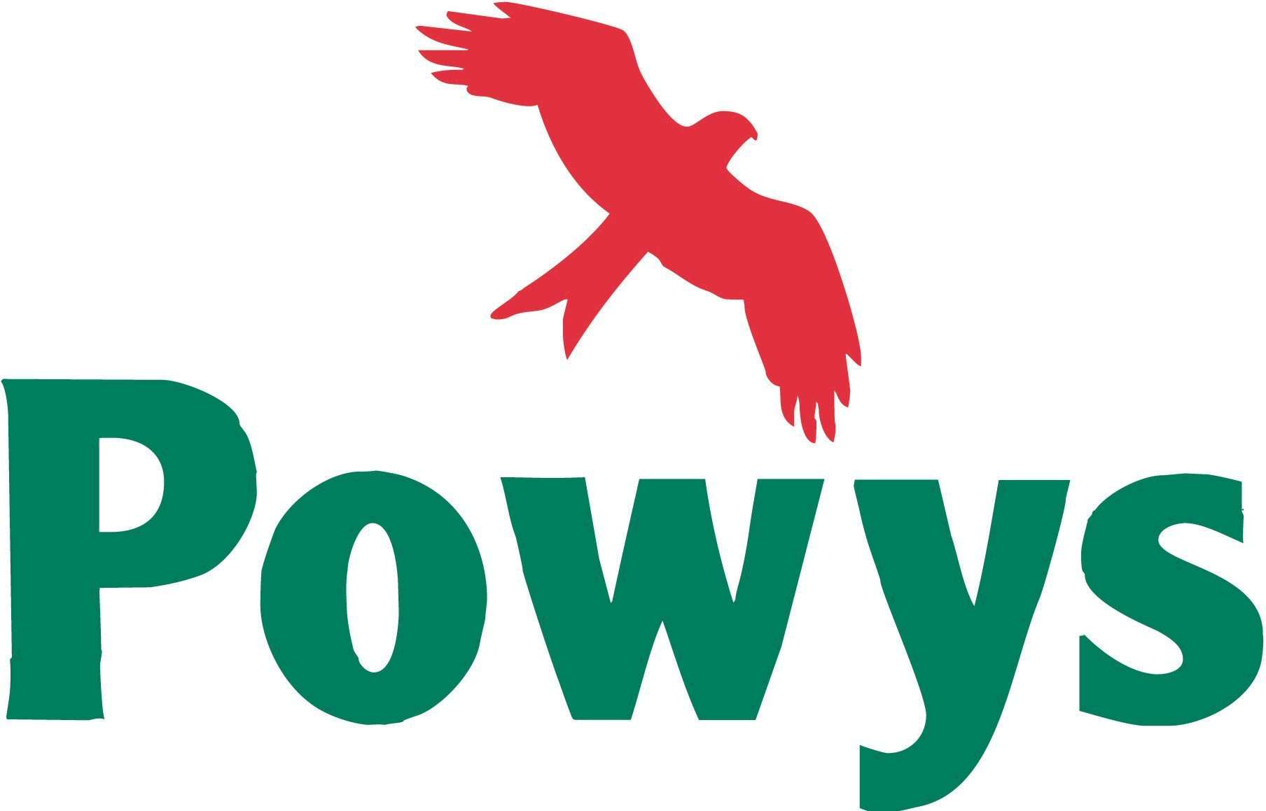 | For Office Use
 | LDP Representor No:
 | Date received:
 | Action: / scanned / copied / acknowledgement / entered:

Adopted Powys Local Development Plan 2011-2026

Draft Supplementary Planning Guidance (SPG) Consultation
Representation Form July 2018

It is recommended that representations are made on this standard form. A separate form is available for each different SPG. More copies are available at Powys Council offices and at local libraries where the Draft SPG is available for public inspection or online at www.powys.gov.uk/ldp

Please use this form to comment on the Affordable Housing SPG.

Send your completed form to:

Powys LDP Team
Planning Policy
Powys County Council
The Gwalia,
Llandrindod Wells,
LD1 6AA or via email to LDP@powys.gov.uk

Representations must be received by 5.00 pm, Tuesday 21st August 2018.

Group Representations

Where there are groups who share a common view on matters contained within the SPG it would be very helpful for the group to send a single representation which represents that view. Groups should indicate how many people they represent and how the representation has been authorised. The group’s representative should be clearly identified.

Data Protection

Personal Data will be processed in accordance with the General Data Protection Regulations 2018 (GDPR). We collect the data to ensure good practice - openness, transparency and collaboration - in the way the Council carries out its statutory planning functions under Part 6 of the Planning and Compulsory Purchase Act 2004.

Powys County Council will be data controller for any personal data you provide as part of your response to the consultation. The data is stored in the LDP digital database and each person/organisation is given a unique identification number. We will only use the data for the purpose of the LDP process including the preparation of supplementary planning guidance (SPG) and do not share the information unless obliged by law to disclose it.

Any comments that you send to us will be seen in full by Planning Policy staff dealing with the issues which this consultation is about. In order to show that the consultation was carried out properly and to inform the public, the Council intends to publish a summary of the comments made to the consultation. We do not routinely publish comments in full, however, in certain circumstances we reserve the right to publish comments in full which may include the name of the person or organisation who sent the comments together with a unique identification number. If you do not want your name published, please tell us this in writing when you send your response. We will then redact any identifying information before publishing.
All personal telephone numbers, addresses and email addresses will be treated as confidential.

We will retain your information for as long as required for the purposes outlined above or, to comply with statutory requirements or, unless you ask us to remove it. If you require your data to be removed from the LDP database in accordance with the GDPR you must notify us directly in writing to:
The Planning Policy Team
The Gwalia
Ithon Road
Llandrindod Wells
LD1 6AA
Or by email to LDP@powys.gov.uk

Please note that if you request removal from the database you will receive no further consultations in connection with the LDP and SPG.

Under the GDPR, you have the right:

- to be informed about the collection and use of your personal data.
- to access your personal data.
- to have inaccurate personal data rectified.
- to request the restriction of personal data (in certain circumstances).
- to object to the processing of your personal data
- to lodge a complaint with the Information Commissioner’s Office (ICO) who is the statutory regulator.

For further details about the information the Council holds and its use, or if you want to exercise your rights under the GDPR, please see contact details below:

Data Protection Officer
Powys County Council
County Hall
Spa Road East
Llandrindod Wells
LD1 5LG
or, email: Information.Compliance@powys.gov.uk
or, http://www.powys.gov.uk/en/information-mangement/data-protection-and-privacy/

Please note that information provided in Section 2 will be made publicly available. Personal data but excluding your name, as provided in Section 1, will be treated confidentially and will not be made publicly available.

SECTION 1: Personal Information – please complete this section.

 | Your Details | Agent’s Details (if applicable)
Name:  NB. Your name may be published with your comments. | Presteigne and Norton Town Council
Tel: | 01547 528575
Email: | pntc@hotmail.com
Address: | Garn Farm,  Chapel Lawn,  Bucknell,  Shropshire  SY7 0BT
Signature: | Tracey Price
Date: | 19.07.18
Representor Number *: | 525

*You will have a Representor Number if you have made representations at any time during the LDP process or if you have requested to be included on the Council’s LDP database. The Representor number will be clearly indicated on previous correspondence from the Council/Programme Officer. PLEASE QUOTE THIS NUMBER TO ASSIST THE COUNCIL IN IDENTIFYING YOU IF YOU ALREADY HAVE A NUMBER.

If you have not previously made representations and you now want your personal details to be added into the LDP database to receive future communications concerning LDP matters (note data protection notice above) please indicate your consent here:

Please add my personal details into the LDP database: YES / NO (Strike through as required).

SECTION 2: Commenting on the draft Affordable Housing SPG:

Please answer the following questions as appropriate and set out your comments below using additional sheets as necessary. Clearly indicate using page numbers and/or paragraph numbers to show which part of the SPG you are commenting on. Outline what changes you think are needed or what additions/deletions should be made:

AH1 - Do you agree that the affordable housing definitions and types as set out are relevant to the Powys LDP area? If not, please explain why.

Yes.

.
AH2 - Do you agree with the data sources and calculations used to work out the affordability level for Powys? If not, please explain why.

No. We believe the average income, certainly for Presteigne and Norton, if not all Powys is unrealistic and that the average income stated is not only too high but also that it is unlikely that a family unit looking to buy a property would both be earning the stated wage. Therefore the stated ‘affordable’ house price is too high and the gap between that figure and the average house price is much greater than stated.

In addition the number of persons stated as being in affordable housing need in East Radnor is far too low. The Town Councils own housing survey in 2011 identified 80 people within Presteigne and Norton stating they would need an affordable 2/3 bedroom home within three years. Just 11 have been provided in the PNTC area since that time. In 2011 PCCs own housing register had 158 on its housing register (only six of which had completed the PNTC survey so 152 extra).

AH3 - Do you agree with the approach towards seeking affordable housing contributions from specialist market housing developments? If not, please explain why.

Yes.

AH4 - Do you agree with the examples given of circumstances where alternative provision to on-site provision may be considered? If not, please explain why.

Yes providing the monies received are spent within the same community as the original site.

The TC supports the prevention of subdivision/phasing of development sites to avoid Affordable Housing contributions and in defining the density of sites to avoid 4 homes being provided rather than five on a 0.25 hectare site.

AH5 - Do you agree with the approach used to determine whether off-site provision would be appropriate? If not, please explain why.

Yes.

AH6 - Do you agree with the method and formulae for calculating the required financial contribution? If not, please explain why.

Agree with the principle but affordable housing need figures not felt to be even close to correct. See AH2.

AH7 - Do you agree with the examples given as to how the Council may spend financial contributions and with the cascade to be applied? If not, please explain why.

Yes.

AH8 - Do you agree with the sources of evidence to be used by the Council to determine local housing need? If not, please explain why.

Yes

AH9 - Do you agree with the arrangements and information requirements for assessing the financial viability of a specific development and proposals for reviewing viability? If not, please explain why.

Yes.

AH10 - Do you agree with the guidance on assessing the appropriateness of the location, scale and type of affordable housing on exception sites in Towns and Large Villages? If not, please explain why.

Yes.

AH11 - Do you agree with the guidance on determining whether a site should be viewed as infill or as a logical extension in Small Villages? If not, please explain why.

Yes.

AH12 - Do you agree with the guidance on the tests to be used to determine whether a proposal is located within a Rural Settlement? If not, please explain why.

Yes.

AH13 - Do you agree with the guidance and principles to be used in assessing Affordable Housing Schemes? If not, please explain why.

Yes.

AH14 - Do you agree with the process for assessing the local housing need of proposed occupiers? If not, please explain why.

Yes.

AH15 - Do you agree with the approach towards ensuring the provision, affordability and availability of affordable housing at each stage of the planning process? If not, please explain why.

Yes.

AH16 – If you have any other comments you want to make which are not covered by the above questions please include them here:

None.

SECTION 3: What Happens Next?

Planning Policy Wales (9) says in para. 2.3.4 substantial weight can be given “to approved SPG which derives from and is consistent with the development plan, and has been the subject of consultation.” The preparation of SPG however, is not subject to the same statutory process as an LDP. Following this consultation, the Council will review the comments received and make amendments as considered appropriate. A final version of the SPG will be approved by the Council, published on the website and will become a material planning consideration. No Public Examination will be held to consider the draft SPG. Further details can be found on the Powys website: www.powys.gov.uk/ldp.

Completed representation forms must be returned:
BY EMAIL - LDP@powys.gov.uk, or,
BY POST – The LDP Team, Planning Policy, Powys County Council, The Gwalia, Llandrindod Wells, Powys. LD1 6AA

The closing date for representations is 5.00pm Tuesday 21st August 2018.

